MedAssitAI: Medical Symptom Analysis &

Disease Prediction System

Submitted By
Name: Diksha
Team: 2
Role: Fronted

Project Overview
During this milestone, I continued the frontend development of the MedAssist AI project by implementing the Disease Prediction and Risk Assessment module. I also enhanced the application with a role-based dashboard system for different users, including Patient, Doctor, Admin, and Staff. Since the backend is still under development, the frontend has been prepared for future API integration while allowing role-based navigation through a temporary development mode.

Work Completed

1. Disease Prediction Module
I designed the Disease Prediction interface where patients can access the prediction system. The page has been prepared to display prediction results received from the backend in future development.
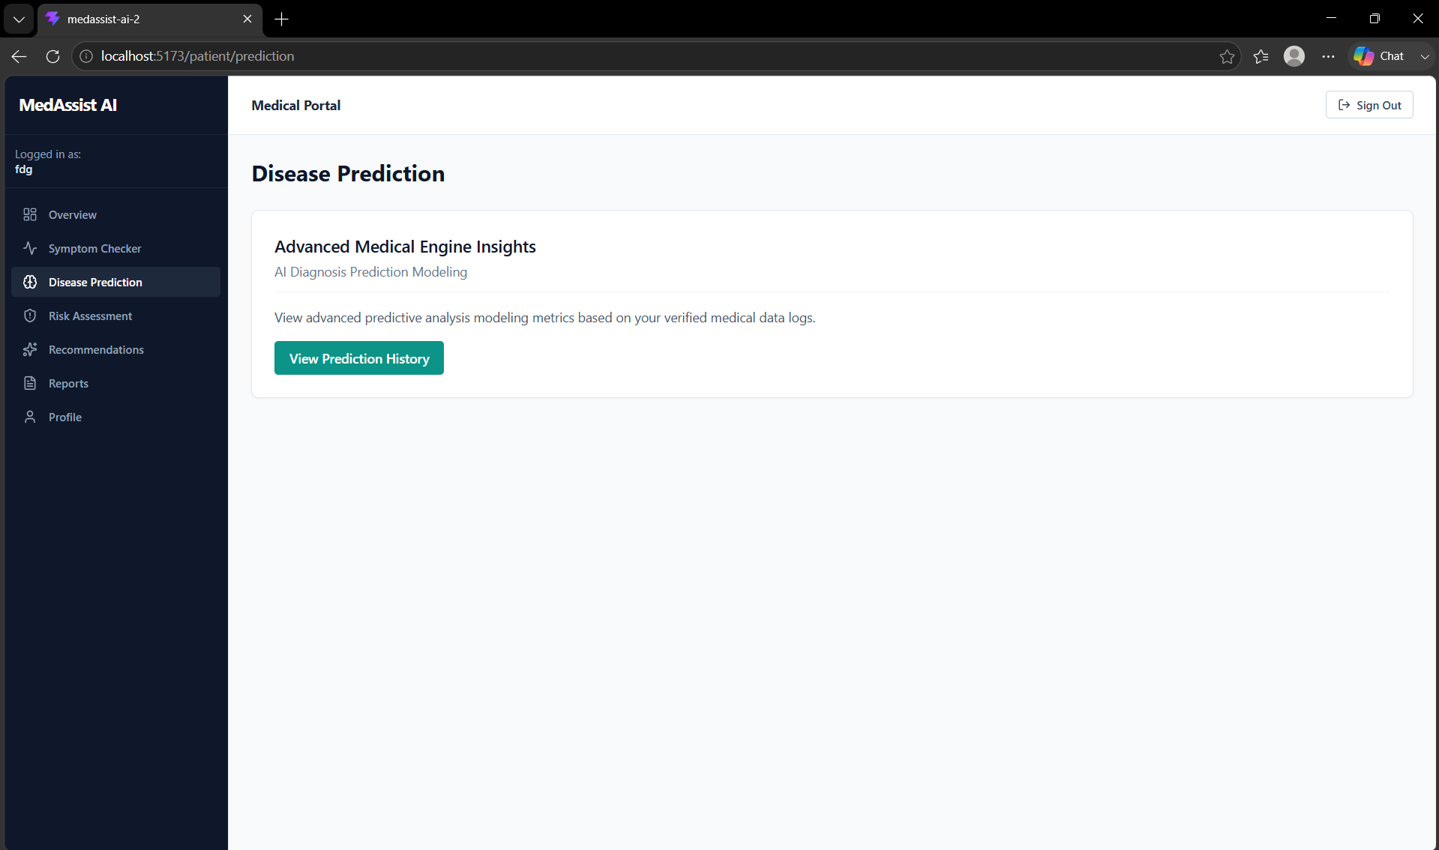

2. Risk Assessment Module
I developed the Risk Assessment page to display patient health risk information. The interface is designed to present future prediction results and risk levels after backend integration.
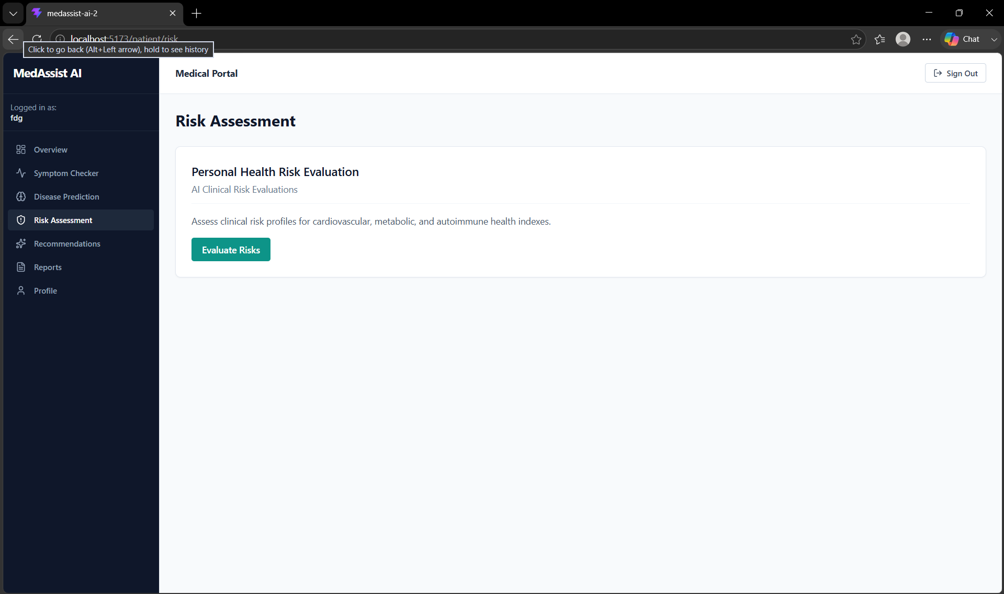

3. Health Reports Module
I created the Reports page where patients will be able to view their medical reports, diagnosis summaries, laboratory reports, and download generated reports after backend integration.
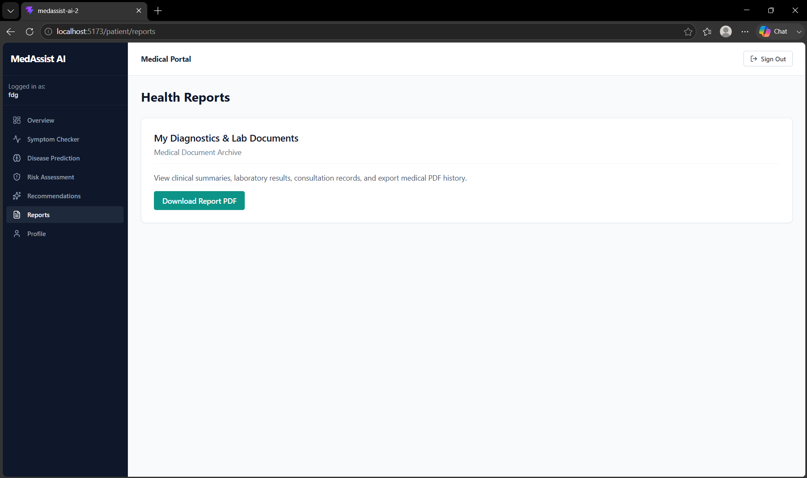

4. Role-Based Dashboard
I implemented separate dashboards for different user roles to improve system organization and user experience.
The following dashboards were created:
- Patient Dashboard
- Doctor Dashboard
- Admin Dashboard
- Staff Dashboard
Each dashboard displays different navigation menus according to the user's responsibilities.
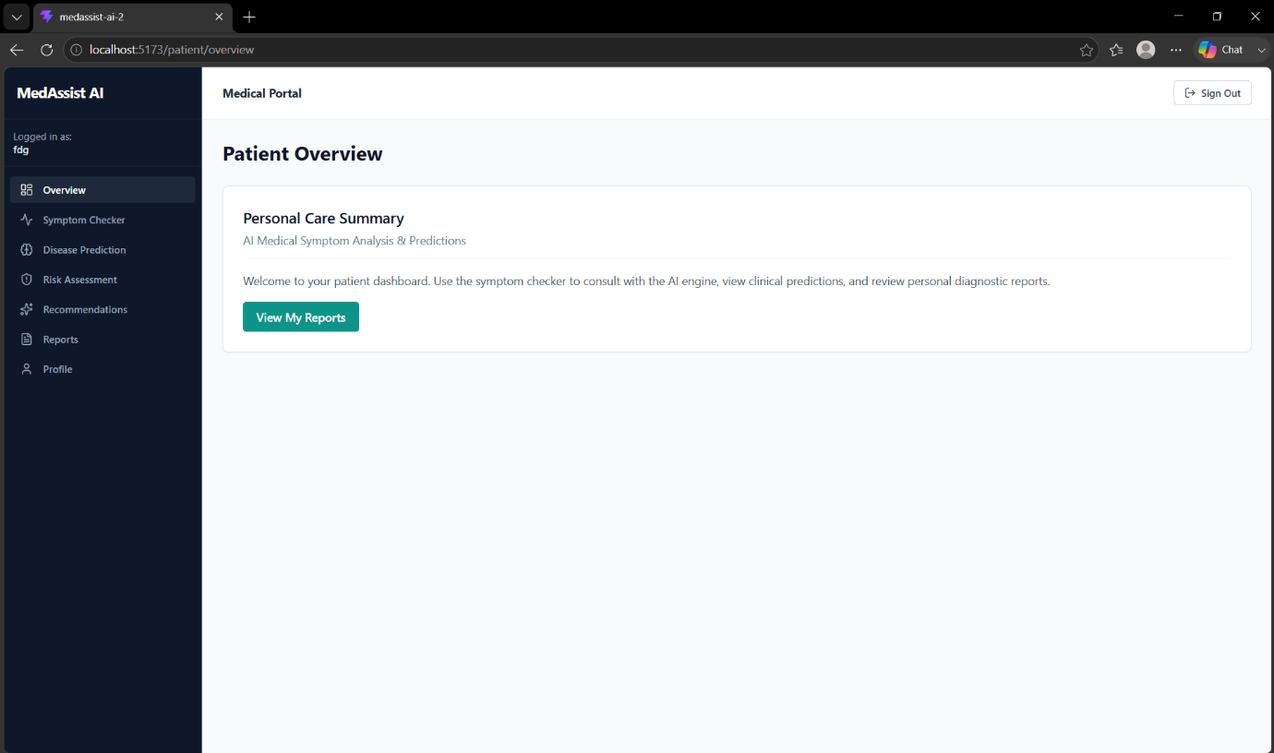
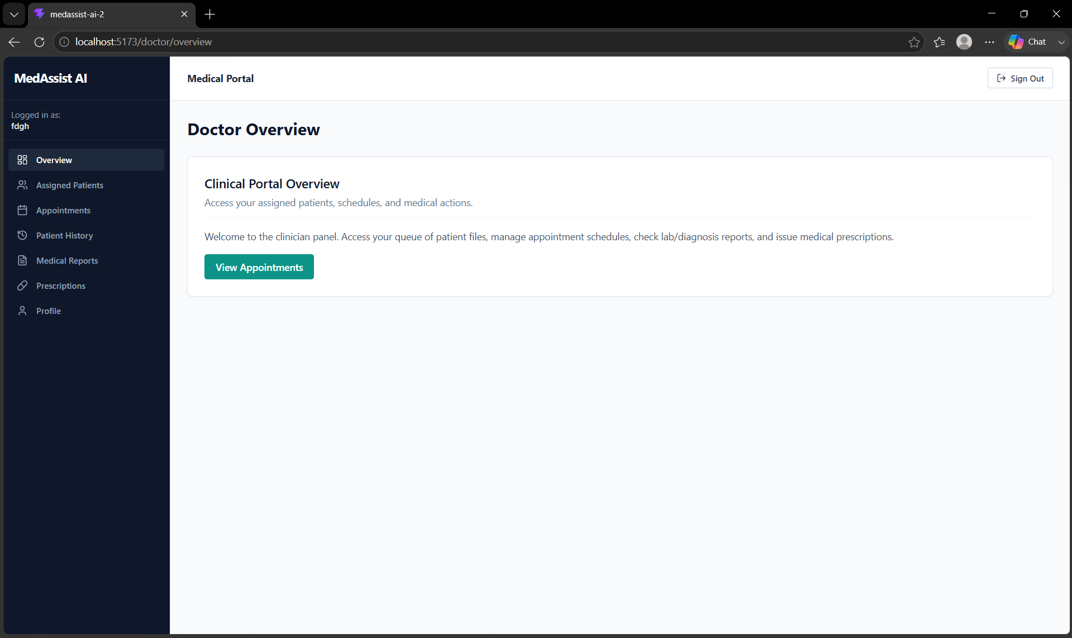
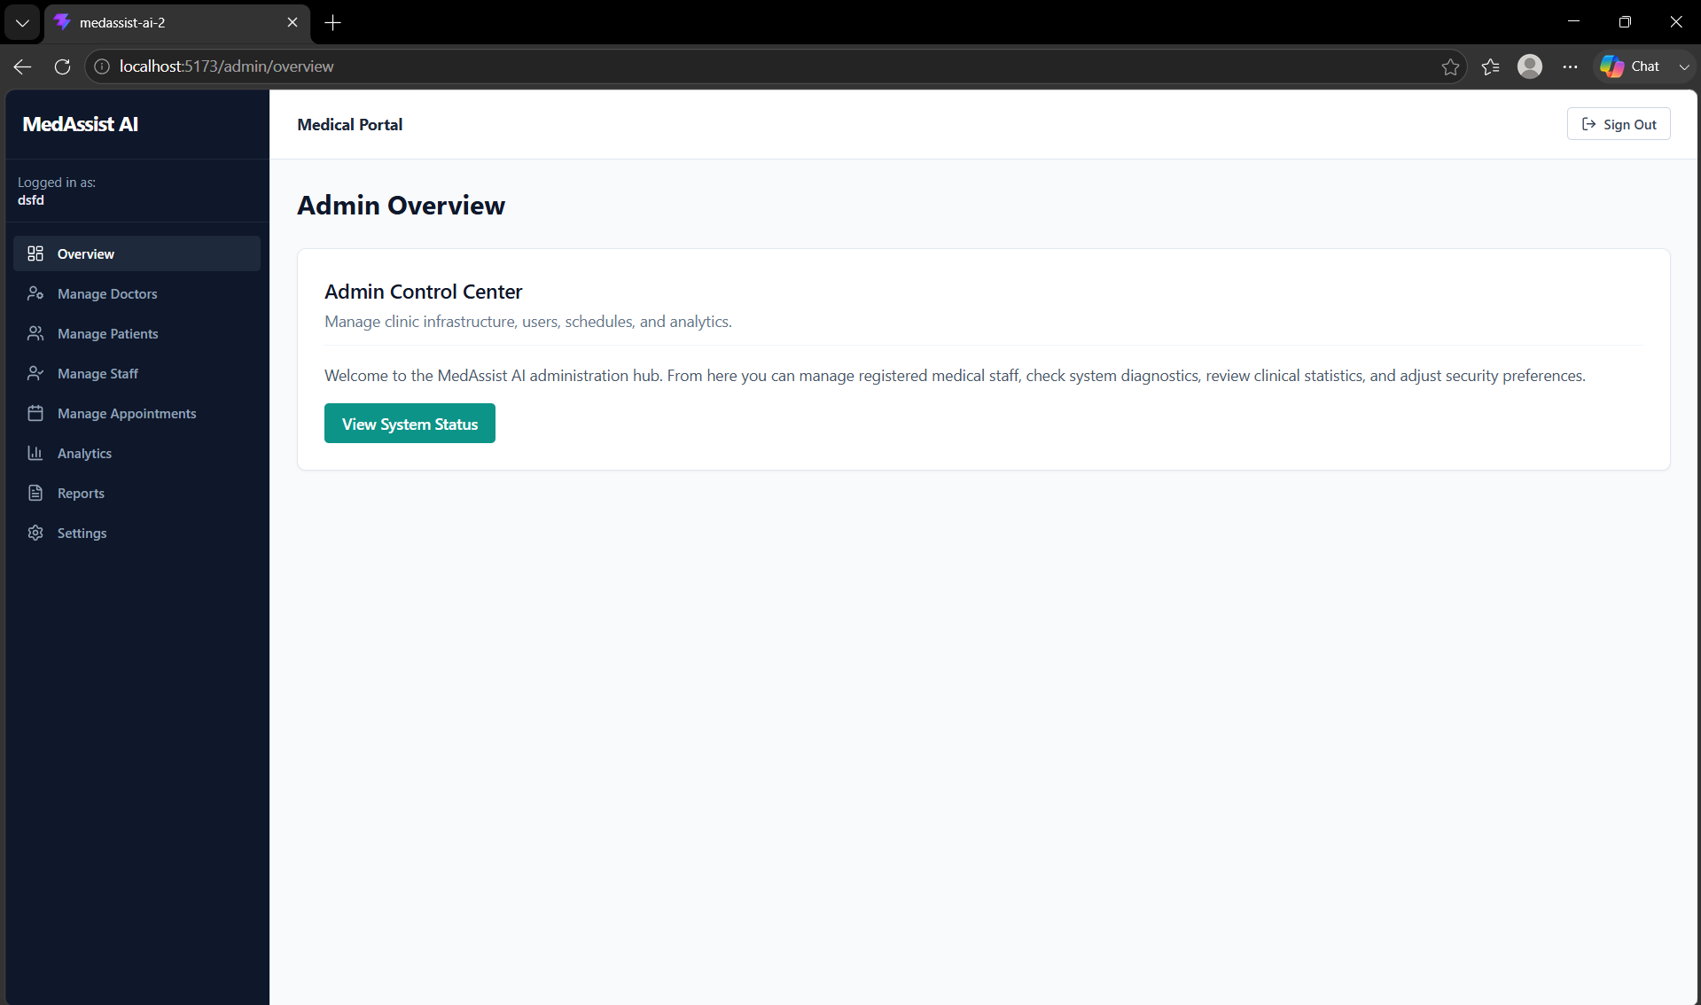
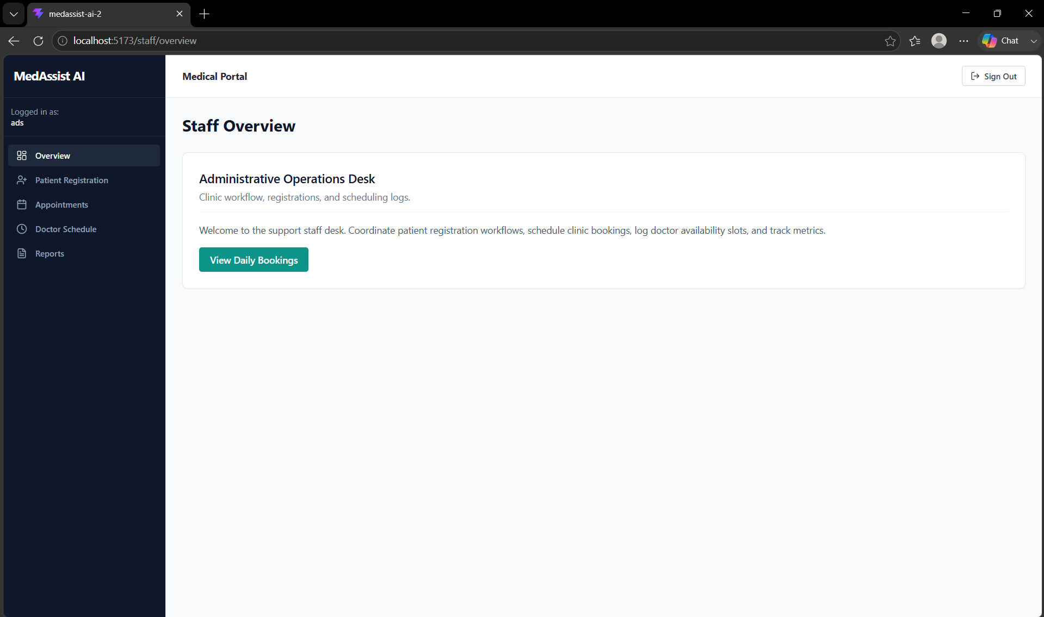

5. Role-Based Navigation
I configured role-specific navigation so that every user only sees the pages related to their responsibilities.
Examples include:
Patient
- Overview
- Symptom Checker
- Disease Prediction
- Risk Assessment
- Recommendations
- Reports
- Profile

Doctor
- Overview
- Assigned Patients
- Appointments
- Patient History
- Medical Reports
- Prescriptions
- Profile

Admin
- Overview
- Manage Doctors
- Manage Patients
- Manage Staff
- Manage Appointments
- Analytics
- Reports
- Settings

Staff
- Overview
- Patient Registration
- Appointments
- Doctor Schedule
- Reports

6. Role-Based Authentication Structure
I enhanced the authentication structure to support multiple user roles using React Context and Protected Routes. The frontend now supports role-based access control and is prepared for backend authentication integration.
Since the backend is not yet available, the application currently operates in Development Mode, allowing temporary role selection to demonstrate different dashboards and user permissions.

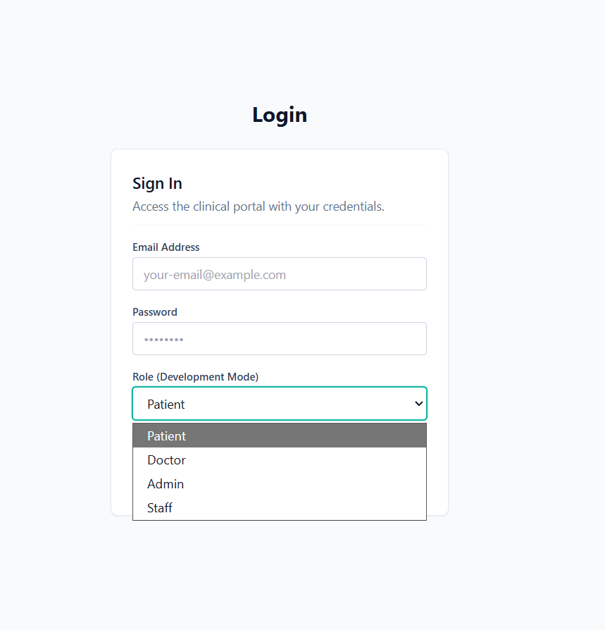

7. Protected Routes
I implemented reusable Protected Routes to ensure that users can only access pages assigned to their respective roles.
This architecture is ready for backend authentication and authorization without requiring major frontend changes.

8. Backend Integration Preparation
The frontend has been prepared for future backend integration.
The application structure is ready to receive:
- User authentication
- User roles
- Disease prediction results
- Risk assessment data
- Medical reports
- Appointment information
Once backend APIs are available, the temporary development mode can be replaced with real authentication without changing the frontend architecture.

Learning Outcome
Through this milestone, I learned how to implement role-based frontend architecture, create multiple dashboards for different users, configure protected routes, organize user permissions, and prepare the frontend for future backend and AI model integration.

Conclusion
In this milestone, I focused on developing the frontend for the Disease Prediction and Risk Assessment module while improving the overall application architecture through role-based dashboards and protected navigation. Although backend authentication and AI prediction services are still under development, the frontend is fully prepared for future integration and provides a structured foundation for the remaining project phases.

